The Godfather Legacy™

A Television Series Screenplay
by
Garymerle Koeppel

Character Portraits

Contact:
Gary M. Koeppel
gkoeppel@icloud.com
(831) 596 7711

THE GODFATHER LEGACY LOGLINE

When a notorious Mafia Godfather is pardoned from prison and murdered by his gangster daughter, an unknown son inherits $33 billion that he plans to spend on good works, but when the sister he never knew learns about the money, she plots to kill him and take the money to expand her criminal empire, which triggers a life and death struggle for the Godfather Legacy.

THE GODFATHER LEGACY CHARACTERS
Photos are character portraits envisioned by Screenwriter.

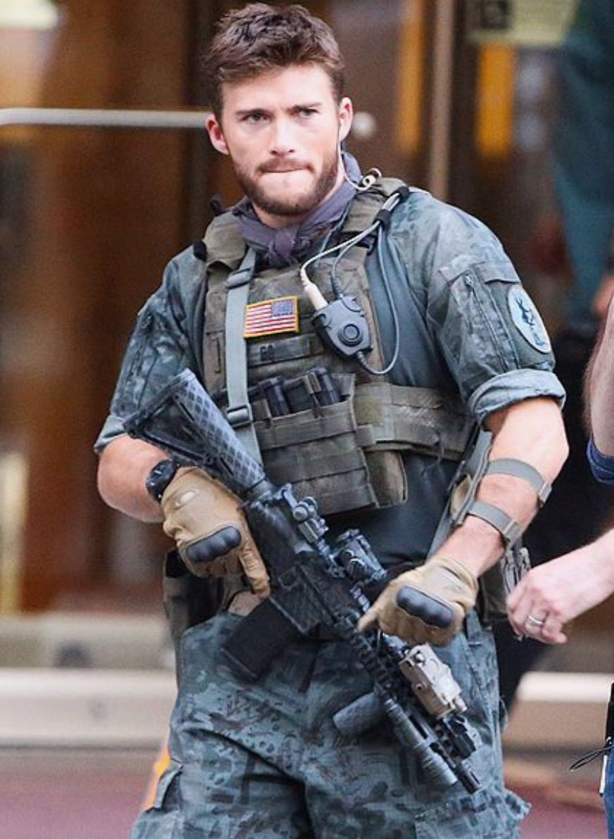
SCOTT ADAMS, (29)
Son of Godfather Antonio Costellano

Scott Adams is the son of father he never knew, Antonio Costellano, a New Jersey Mafia Godfather, whose wife Katherine lied and told him she had aborted their son.

She did not want him raised in a crime family so she gave Scott to her sister and husband to raise in California. Her sister Susan was a loving stepmother dedicated to Scott, but his stepfather Arnold, resented him because he disrupted their active social life and luxurious lifestyle.

On his 16th birthday Scott bought an old Scout pickup for $25. Arnold, a car buff, helped Scott restore the vehicle, which became their only subject of mutual interest.
Scott began driving to the Adam’s old cabin in Big Sur that Arnold had inherited from his father. He loved being alone and feeling free. He hiked down the rugged cliffs to the remote beaches and up the steep canyons along the narrow animal trails to the high ridges overlooking the Pacific Ocean.

A canyon fire damaged the cabin and Arnold hired a reclusive mountain man to rebuild it, an old-timer the locals fondly called Uncle Al.

Scott was intrigued by Al, an expert boar hunter who lived with his hounds in a rusty trailer on the Old Coast Road. Part Esselen Indian, Al treated young Scott as an equal. Scott trusted his honest and simple ways, his love of the land and his wisdom of times past.

Soon after getting his driver’s license, Scott moved into the Big Sur cabin. He lived alone until graduating with eight other seniors from the local Captain Cooper School.

Eager to explore the world, Scott joined the US Army and became a Captain in the Ranger Special Forces. He served three tours in Afghanistan with Operation Enduring Freedom before being wounded by an IED. He was discharged and assigned to a rehabilitation center hospital in Maui, Hawaii.

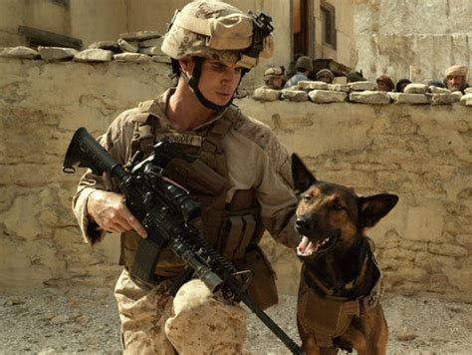
Shadow and Scott on Patrol

The grim experiences of death, destruction and unspeakable atrocities in the desert destroyed Scott’s innocence and thrust him into the realities of a vastly different world than he had known as a boy.

While rehabilitating in Hawaii, he could not regain his peace of mind. He swam daily in a little-known cove in Makenna, a remote area of the island, and walked endlessly on the beach without purpose.

One day, while snorkeling far offshore, a woman surfer accidentally struck him in the head with her board. He was knocked unconscious, but she saved his life by floating him safely to shore on her board. She then dressed his head wound and nourished him back to life in her parent’s old Hawaiian house near the beach.

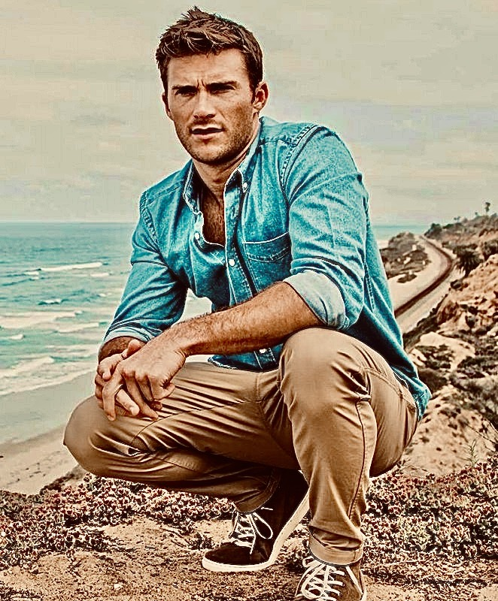

During those peaceful days, Scott fell in love with her gentle ways, her melodic Hawaiian voice, and graceful movements. His body began to recover from his war wounds.

His recurrent nightmares of the two young Afghan girls brutally raped and killed in front of their parents began to wane. His love for Leilani grew slowly into a strong love. He proposed while swimming in the same cove where they accidentally met.
When Scott asked Leilani to come to California and live with him, Leilani was torn between her love for him and the sadness she felt about leaving her ancestral home. She fears her doubts could one day surface and threaten their love and life together.

At home Scott struggles with finding himself after his tours in Afghanistan. He and Leilani spend their time repairing the old family cabin in Big Sur and painting houseboats in Sausalito. He tries everything to find a new place in his old world. He even has a wild idea for a startup business marketing idea, but it goes nowhere. He feels like he is floating in time.

Trouble brews between them. Scott broods about his future and Leilani longs for her native island and finds refuge in painting nature scenes. Scott senses he is losing her and sees how she fawns over a Big Sur sculptor who is trying to woo her from Scott.

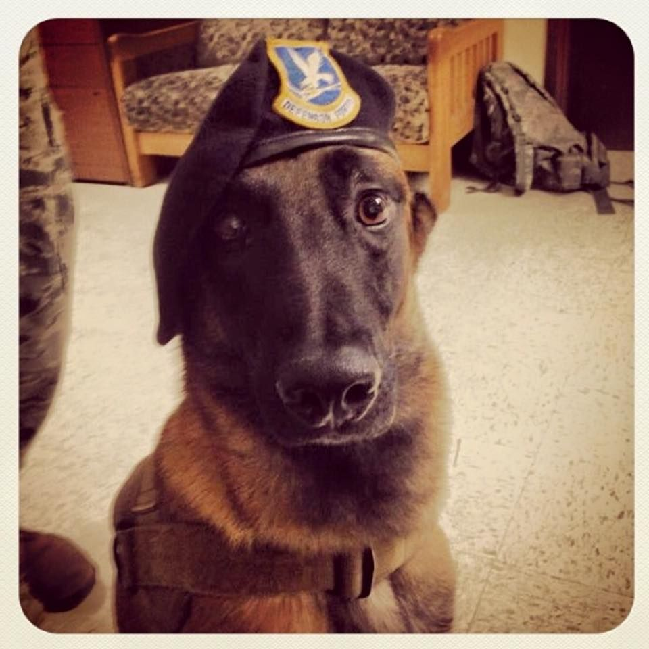
SHADOW, (8)
Scott’s Army Service Dog
Shadow is Scott’s highly decorated US Army service dog who retired with the coveted K-9
Medal of Honor. Countless times he saved the lives of Scott and his Ranger Team in ferocious desert fire fights.

Shadow is a highly trained professional known for detecting explosives. He is a fierce warrior that responds to one-word commands: Search. Attack. Hold. Kill.

Shadow took a bullet meant for Scott who, in turn, saved his life and brought him home. Shadow is Scott’s closest friend and Leilani’s fiercest protector.


ANTONIA (SOFIA) COSTELLANO, (30)
Antonio Costellano’s Daughter
Scott Adams’s unknown Sister

When Mafia Godfather Antonio Costellano’s wife told him she had aborted their son and his only heir, he beat her savagely and banished her. He was unaware that she had lied to him. She secretly gave birth to his son and gave him to her sister to raise. She did not want him growing up in a crime family.

Antonio soon took refuge in his beautiful, immigrant Arab maid, DURRI HADI, who he had purchased from human traffickers, but when she became pregnant, he was conflicted. He wanted a son, preferably an Italian son, but at his age he needed to secure his legacy. He would consider any son that had his blood—even from an Arab.

But when the ultrasound identified the baby as a girl, he was angered by losing his second chance for a bloodline son. He exiled her into an apartment where she could continue fulfilling his sex needs and where he could punish her for not bearing him what he wanted most, a son.

Durri was devastated. She had grown up as a Sunni Muslim in Qatar in an upper middle-class family, but was abducted, shipped to America and sold to Antonio Costellano where she serviced his sex needs and worked as his maid. She was his beautiful captive lover who fell in love with him and dreamed of bearing his name as his wife.

Durri coveted the power of the Costellano name and the respect it commanded. She gave her daughter Italian names, Antonia Sofia Costellano thinking Antonio would accept her. Instead, he forbade her use of Antonia and Costellano. She was called Sofia Hadi, although both mother and child used the name Antonia when together.

As Antonia grew up, her love for her mother grew daily. Durri was kind and caring. She wrapped her precious daughter in a cocoon of protection and love. For Antonia, Durri was her doting mother and best friend with whom she laughed and played and felt safe. They had a special mother-daughter love.

They shared everything and had no secrets. Whenever Durri wanted to tell Antonia something important, she would call her, Antonia Sofia Costellano Hadi. They often wrote notes to each other about their dreams and hid them in places the other would be sure to find.

Antonio never recovered from his inability to bear a son and heir. He visited Durri for sex, which became increasingly rough and loveless. As Antonia grew into a child, she would hide in the closet listening in terror as Antonio’s sex with her mother ended with a beating. As she grew up, Antonia’s inability to defend her mother turned from fear to helplessness to hatred. She vowed that one day she would take her revenge.

When Antonio visited Durri, he would order SALVATORE “SAL” ROSSI, his bodyguard, to distract young Antonia. She came to trust his kind ways and called him “Sallie”, and he called her “Little Tonia” and a mutual trust began to bond them.

Despite Antonio’s abuse, Durri remained loyal to him and her fantasy of becoming a Costellano. She was too proud to be a kept woman and refused Antonio’s money, but he always left her guilt cash. She found work as a maid during daytime, leaving Antonia alone. As Antonia grew up, her inability to defend her mother turned to confusion and despair. She vowed that she would take her revenge.

At age ten, Antonia was shooting marbles, tossing dice and winning money. One day she won from the block bully who punched her and took her winnings. Sal agreed to help her learn self-defense and she began by building strength in a gym.

During the next few years, she mastered the self-defense arts of Aikido and Karate, then graduated to Kung Fu Martial Arts. Over time, she persuaded Sal to teach her how to kill from his experience in the Marine Corps Martial Arts Program. Sal sensed she was training to kill the very man he was paid to protect, her blood father Antonio.

Antonio stopped visiting Durri and to punish her he stopped giving her money for rent and food. Her dreams of becoming his wife turned into dark and bitter memories. She became depressed and turned to drugs, then sold her body to support the addition. Antonia watched her mother become suicidal. Her hatred for Antonio turned into silent, sullen and cold rage.

By age 12 Antonia’s body was pure muscle from Sal’s daily training. Walking home one day, a drunk vagrant grabbed Antonia and knocked her to the ground. She poked her thumbnails in his eyes. When he stood up screaming, she kicked him in the groin, picked up a piece of metal and struck him in the head until he lay still. She later told Sal his training had worked, that her reaction was automatic, and she was excited by the feeling of power her defense gave her.

By age 15 her mother had become a stranger, a victim of her addiction. Antonia’s earnings from a part-time job did not pay for her drugs. Durri became an empty body for anyone willing to buy her while Antonia was in school.

Late one afternoon Antonia came home to find a huge naked man grunting loudly as he penetrated the dead body of her overdosed and suffocated mother. In a burst of rage, Antonia killed him with a kitchen knife She tried breathing life into her mother but collapsed in despair. She called Sal and he took her to Antonio’s, who reluctantly let her stay. Antonia was comforted knowing now she was close to her hated enemy and in time would avenge the way he treated Durri.

The year Antonia celebrated her 18th birthday, Antonio Costellano was convicted of racketeering and sentenced to life. During the first five years of Antonio’s imprisonment, Sal acted as his Capo but could not sustain the failing business. Antonia learned from his failures, studied business in night school, and began bringing Sal new ideas that would convert the criminal operations into legitimate businesses.

Antonia’s DNA test proved that Antonio was her father. She legally changed her last name to Costellano. Because of the Mafia code of blood succession, Antonia was declared the family Boss. Sal gladly relinquished control and became her first lieutenant and bodyguard. She paid for Antonio’s protection in prison and plotted to keep him alive for a more personal death.

During the next twelve years Antonia revolutionized the family crime business by converting a failing criminal empire into a thriving corporate conglomerate. She named it ACE, an acronym for Antonia Costellano Enterprises, that soon became a well-known, new-generation business operated by a female entrepreneur who was becoming a successful business magnate.

Five Aces Inc
Antonia sold off the family brothels, drug operations, protection rackets and bookie joints. She created a model agency, bought a pharmaceutical plant, built a data bank, opened a casino with an online gaming site, and minted a cryptocurrency to capitalize her conglomerate empire.

The ACES INC corporate office is in the Five Aces Hotel and Casino one floor below her private penthouse, from which she travels by helicopter to and from her Lake Tahoe home. Her private jet, ACE ONE is hangered at the Executive Jet Center of the Reno International Airport.

The ACE-MODS is an Executive Escort Service featuring beautiful male and female models who are professional sex providers and skilled corporate spies. They are specifically trained to gather information used to control, manipulate and blackmail corporate clients. When entertaining clients, they wear contact lens with cameras that record and transmit videos directly to ACE DATA for storage and processing. Her Escorts also wear micro earbuds that receive and record instructions conversations.
ACE-PILLS is a drug manufacturing plant located offshore in Panama. Through bribes and blackmail, permit bureaucrats at the Food and Drug Administration provide FDA Certification and Approval that allow her to manufacture and distribute dangerous, addictive and otherwise illegal drugs openly, over the counter. The addictive pleasure drugs are used to control clients and the addictive destructive drugs are used to eliminate them.

ACE-DATA is a cloud computer facility and data management center that stores the digital information, conversations and videos of all clients in the ACES INC’s network. Data is gathered from all operations and retrieved when needed for intimidation, manipulation, bribery, corporate sabotage, insider trading, and more.

ACE-BETS owns the Five Aces Hotel and Casino in Reno. It is famous for including a fifth ace in every deck of cards, allegedly to improve a gambler’s odds. The online gambling website that is domiciled offshore uses only the ACE-COIN cryptocurrency for all bets and payouts. The exchange price between the ACE-COIN and international currencies is calculated by an ACES DATA algorithm that guarantees the profitability of each gambling operation.

ACE-COIN is a cryptocurrency Antonia designed to use instead of dollars for capital purchases, business expenses, pay offs, gifting and charitable donations. The coin price is controlled by an ACE-DATA algorithm that manipulates the price when buying or selling an asset.

The Lake Tahoe Lodge
Antonia oversees the operations from her penthouse atop the Ace Casino and from the Costellano Family Lodge on the Lake Tahoe waterfront, a gated compound inside a 1200-acre ranch. The property includes several inlets and beaches along two miles of lakefront. The Lady Ace motor launch is moored in the boathouse and the Ace One helicopter is parked in a nearby helipad. Dirt roads, hiking and riding trails weave throughout the property. The spacious home consists of numerous rooms and Antonia’s modern office with views of the lake.

A network of security cameras surveils and records any movement throughout the property. ACE DATA collects, stores and monitors the data and transmits security breaches to the Guard House and Main House monitors.

The Lake House staff includes a chef and maid, who are a happily married couple, a groundskeeper and three security guards. They live on the estate in nearby homes except Uncle Sal, who lives in a large, private guest wing of the main house where he can conveniently counsel and protect her.

Antonia’s Lifestyle
Antonia is a very private person with no immediate friends except Salvatore, her lieutenant, confidant and personal bodyguard. She enjoys her body and her beauty, often flaunts it, but always uses it with her brain to get whatever she wants. She is bisexual and enjoys the pleasure of both men and women and, on occasion, both at the same time. She enjoys quality and good taste in fashion, décor, design, food and travel.

Antonia works out daily, runs several miles along a private path in the compound, and keeps her body muscles toned and ready. She is a long-distance swimmer who can tolerate cold water and stay under water for long periods of time.

She is an excellent shot and carries a Sig Sauer P238 revolver with a permit when traveling out of the compound. On the target range she practices with a Swiss VO Vapen, a three-piece rifle that fits into an attaché, a special gift from her best friend, training mentor and security chief, “Sallie”.
Antonia lives a classy and glamorous but busy and very private corporate life. She pays all taxes and obeys all laws. She avoids publicity and what she calls “loud” -- anything that broadcasts too much success and wealth that would attract attention. Her cars are all conventional white Mercedes.

She adores pets from a distance but avoids human involvement and dependencies. A few chocolate Siamese cats roam the estate but come and go with independence and disregard, although one cat, Crescent, will occasionally steal into her bed at night. She has three horses in the stable and two Doberman Guard Dogs that live with the Security Guard in the Carriage House.

Antonia’s Dark Side
Antonia murders people with ruthless cruelty. She kills only after meticulous planning and with contempt, but never with personal emotion. She has never personally killed since stabbing the obese man who suffocated her mother and copulated with her corpse. When ordering Sal to kill someone, she calls it “retiring them”, which is usually a business decision to solve a problem or make a profit.

Although she knows how to kill from her Martial Arts training, she delegates her order to Sal who in turn delegates the “retirements” to others to fulfill. Her preferred weapon is poison, a subject she studied and in which she has become a lethal expert.

Antonia does not like to touch or be touched by anyone except during sex. When having sex with men or women, she also prohibits them from talking and commands silence. Except for Sal, she regards all men as devious , untrustworthy and to be used only to further her ends. She has no female friends and regards most women weak and simple-minded, domestic slaves.

Antonia prefers the color white, which is everywhere: her clothing, décor, furniture, vehicles, yacht and jet. To her white signifies clean, simple and pure. It obscures anything that might otherwise present itself to be dark and evil. Encircled by white, she feels safe, comfortable, and good about herself.

Antonia has succeeded in converting illegal activities into legal entities by corrupting the law from within. Yet, this success is not enough for her. She is possessed to settle the score with Antonio. She bribed the Governor for a Pardon to free Antonio so she could extract her very personal revenge and kill him.

It is here The Godfather Legacy begins.


SALAVATORE “SAL” VINOSA, (60)
Antonia’s Lieutenant and Protector

Salvatore Vinosa was born in Harlem in Project Housing. His Mississippi Mama never married his Italian father, who managed the building where they lived. When growing up his Mama would often remind him, he was born the same year as Rosa Parks, saying “Don’t you be giving up your bus seat to nobody lessen it be a pretty black girl”.
Young Sal was always comfortable in his skin color and had an easy way about him that put both blacks and whites at ease, as if he belonged to whichever race he was with at the time. But he did not waffle from who he was or where he came from. He accepted life the way it was and other people liked him for his simple, direct and kindly ways.

One day a stranger came to the door and spoke to his Mama in hushed words. She cried for days. His Papa no longer visited Saturday nights, but Sal never missed him.

He made friends easily and always took a middle ground in resolving disputes, which strengthened his own confidence and others’ as well. He moved between the ghetto culture in the projects to the academic culture at school. He discovered ideas and books and language, and in all, he excelled and became a confident, educated man.

When he graduated, his favorite instructor wrote a letter of recommendation that, with his high-grade average, helped him earn a scholarship to the City College of New York.

However, he was soon disillusioned because the black students treated him like half-white trash and the white students treated him like half-black trash. Both kept their distance from him. He learned most of them lazed through their studies during the week and partied hard on the weekends, all the time spouting halleluiah lines from the bible, but not living up to them.

One Friday night some black fraternity members taunted him for spending time with books rather than with them. He lost control and hit one of them. They ganged up and beat him soundly, so he took up Martial arts and learned how to defend himself.

His Mama died during the next summer and he lost his heart for learning. He quit the college, sold her furniture, filled a backpack and hitch-hiked across the country. He marveled at its size and diversity. When he arrived in Reno, he was dazzled by the casino lights and its casual lifestyle. Here he was accepted everywhere by everyone.

Sal used the money from selling his mother’s furniture to take a night course to become a casino dealer and croupier. He got the top grade upon graduation and was hired by the Golden Nugget where he dealt cards, rolled dice and spun the roulette. He saw players lose and the house win almost every time.

One night a Whale sat down at his table and ordered the Pit Boss to clear the table of other players. Sal dealt him cards with no breaks or change of dealer. The Whale was allowed to change the game at will between blackjack, poker, 5-card draw, 7-card stud and Omaha Hi. The Pit Boss brought tray after tray chips, each one with fewer chips but of higher value, and the Whale continued to lose.

The Whale changed from being jovial to sullen and then angry, but always with a cigar protruding grossly from the middle of his mouth. He ordered a $50,000 tray and asked Sal if it were his money, what game would he choose. The Pit Boss nodded approval for Sal to answer him. When Sal told him “none”, the Whale asked why and Sal replied, “I don’t like losing”. Stunned, the Whale cashed in and toked Sal a $1000 chip. When he left, the Pit Boss told Sal he had discouraged play and fired him.

The next day Sal went to work for the Whale, Mafia Boss Tony Costellano. Despite his color and not being an Italian, over time Sal came to be his trusted lieutenant, his Capo. When Antonio expelled his Arab lover and housekeeper, who was pregnant with a baby girl he denied was his, Sal felt sorry for them and decided to watch over and protect them.

Sal became fond of the child, Antonia. One day she was attacked by a homeless man so Sal took her to a gym to learn Martial Arts to protect herself, as he had done when a college freshman. When Antonia stabbed and killed a man in rage who was raping her dead mother, Sal rescued her and asked Antonio to take her into his home to raise.

After Antonio had been in prison for a few years, Sal failed to salvage the failing family crime businesses. When Antonia took a DNA test proving she was Antonio’s blood daughter, the Mafia code declared her to be the family Boss. She chose Sal, her best friend, as her bodyguard and trusted Capo.

Antonia brought new ideas into the family. Sal helped her sell all of Antonio’s old crime businesses of neighborhood protection, street drugs and brothels. But against Sal’s counsel, she kept the human trafficking business. She used the money to establish a corporate conglomerate that had the appearance of being completely legitimate but in fact was covertly criminal.

Although others think of Sal as Antonia’s Capo, she thinks of him as her partner and best friend as well as her operations lieutenant in whom she can entrust her every secret and nefarious deed.


LEILANI KAMAKA’A KALI’I, (27)
Scott’s Hawaiian Fiancé

Leilani Kali’i’ is one of the few remaining, one hundred percent, pure Hawaiians born of royal heritage. She is the only surviving great granddaughter of Queen Liliuokalani, the last sovereign monarch of the Kingdom of Hawaii. She was forced to abdicate her throne and was imprisoned.

Leilani graduated with honors from King Kamehameha school and was crowned Queen of the Hawaiian Arts Festival where she won the coveted competition of the Sacred Art of Hula. She received university degrees in art and Polynesian cultures.

Between studies, Leilani spent as much time as possible surfing waves and Hula dancing. She danced privately on sacred heiaus performing ancient ceremonies. She even enjoyed dancing for tourists in island resorts to share her gift of hula and Hawaiian cultural traditions.

She met Scott by accident when her board struck him while surfing in Makenna Cove, where her family home had been for two centuries. She floated him back to shore on her board and tended his wounds. When he awoke, at first sight, they fell in love, which grew strong as she nurtured his wound and calmed his troubled soul.

Scott soon proposed and she accepted, but with unspoken reluctance. They moved from her beautiful island to California, where they live between Scott’s old redwood cabin in Big sur and the Vallejo Houseboat in Sausalito, which Scott is painting to support them.

For the first time in her life Leilani knows true love. It is rare for a pure Hawaiian to fall in love with a Kane ke’oke’o, a white man, because of the importance of blood line descendants in the Hawaiian culture.

Their life is simple and poor, but full of love and trust until Scott inherits a vast sum of money. After that, she becomes increasingly afraid that the power of money and Scott’s use of it will destroy the power of their love.

She begins questioning her feelings for Scott and is increasingly fearful for their future together. She longs for her ancestral home and the ways of her people.

She has three brothers, all of whom are still living in Hawaii. Her brother Kane is a successful general manager of a resort in old Hana Town on Maui. Keola lives in Lahaina and is an activist in the Hawaiian Sovereignty Movement who wants to restore the governance of the Hawaiian Monarchy. Her third brother, Kimo, lives in Honolulu and is a small drug dealer, petty thief and gambler.

Leilani barely escapes being kidnapped by two derelicts in a homeless camp. Scott avenges her, arrests them and saves two girls they had kidnapped and planned to sell to traffickers in San Francisco’s Chinatown.

When Scott inherits a large fortune, he devotes himself to carrying out good works with the trust fund money that was seeded by criminal deeds. But his increasing attacks on a local trafficking ring with his old Ranger team takes its toll on their relationship. Even though she becomes involved in providing shelter to the victims he rescues, they become estranged. She slowly withdraws into her painting. Unwittingly this attracts the interest and attention of a Big Sur sculptor, which upsets Scott.

Leilani yearns for the island life she left. She misses the peaceful joy of dancing the ancient hula and the thrilling danger of the giant waves she so easily conquered.


KATHERINE COSTELLANO BROWN (57)
Scott’s Mother and Antonio’s former wife

Katherine Brown fell madly in love and married Antonio Costellano when he was an aspiring young man who wanted a life outside his Mafia crime family. But when he was drawn back into their world and became the Godfather of the Costellano crime family, her love turned to fear, then distain.

She lived in terror and succeeded in refusing his advances until one night, in a drunken rage, he violently raped her.

She became pregnant and attempted suicide
but failed. She was terrified that their son would grow up in his crime family, so she lied and told Antonio she had aborted the baby. Outraged, he exiled her from his life.

But instead of aborting the child, she gave birth to a son and entrusted him to her sister and husband to raise in their safe if modest home in California.

When Antonio was convicted for RICO crimes and imprisoned for life, his former consigliere, Tom Harper, helped her escape and became a godfather to her son.

Soon Katherine and Tom married, changed their last names to Brown and moved to Maui to live a quiet life in a small plantation home. The walls were filled with photographs of Scott sent by her sister. That way they could watch him grow from an infant into manhood.

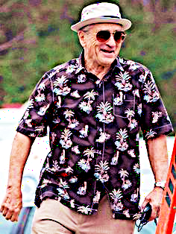
TOM (HARPER) BROWN (60)
Katherine’s Husband and
Antonio’s former Consigliere

Tom Brown, formerly Tom Harper, was originally hired by Niccolò Costellano, Antonio’s father, who hired him fresh out of Columbia Law School.

Niccolò lured Tom into the family business by claiming he wanted his legal counsel for his legitimate family businesses. By the time Tom learned they were criminal enterprises, it was too late --- he was trapped in the role of the family Consigliere."

Tom counseled Nico’s son, Antonio, until he was convicted on RICO charges. But before going to prison, and unknown to his family, Antonio secretly entrusted Tom with $30 million in Casino skim to invest for him.

During Antonio’s trial, Katherine asked Tom to help her get safely to California where she could have her baby. She named her son Scott and asked Tom to be his godfather. They soon fell in love, married and moved to a plantation house in Maui—but not before changing both their last names to Brown.

Tom Brown became friends with several Maui locals who regard Tom as a harmless retired “Haole” who wants nothing from them.


SUSAN ADAMS, (53)
Katherine’s Sister, Scott’s Stepmother

Susan grew up with her sister Katherine in a small town in Oregon’s Willamette Valley and moved to California to study at the Culinary Institute in Saint Helena, California.

She was hired as a Sommelier by the Pebble Beach Company and was soon promoted to Master Chef of the Resort restaurants.

She met renowned heart surgeon and wealthy Pebble Beach widower, Dr. Arnold Adams, during a charity fund-raising event.

They eloped in Paris and settled into Arnold’s mansion on the 18th fairway of the golf course overlooking the Pacific Ocean.

Neither had any children but both readily agreed to adopt Susan’s sister Katherine’s son whose father was a Mafia gangster.

Although Susan doted on the boy, Arnold was impatient and strict. He resented the child because he changed their social life.


ARNOLD ADAMS, MD, (66)
Scott’s Stepfather, Retired Bookkeeper

Arnold Adams, 65, a retired heart surgeon, inherited his family’s Pebble Beach Estate from his father, a railroad magnet who owned a large share of the Southern Pacific Railroad.

His father had collaborated with the famous Pebble Beach developer, SFB Morse, to preserve the area’s unique beauty as it developed into a private residential and golf enclave.

As a young man he married his first wife, Pamela, in an arranged marriage that was devoid of passion and love. She died an early death from cancer and he became a renown surgeon and antique car collector.

When he met Susan, his vacuous life was filled with passionate love for the first time. Initially he was excited to adopt his wife’s sister’s child and raise a son.

But as time passed, neither he nor the child connected with each other, dashing his hopes of being a father. Instead, it made him feel like a failure, for which he further resented the young boy.

When the family cabin in Big Sur burned during a canyon fire, he tried to work with Scott to repair it. Scott quickly befriended the local boar hunter, Uncle Al, the man he hired to help. Once again, he felt as if he failed.

Arnold was embarrassed when Scott moved from their mansion to the old cabin at 16 and attended the local Captain Cooper school.

After college Scott abruptly joined the Army, further devastating Arnold’s aspirations for him. When Scott returned from Afghanistan with PTSD and a Hawaiian fiancé, Arnold gave up trying to have any fatherly influence.


ANTHONY BIG FISH COSTELLANO (81)
Scott’s blood Father and Mafia Boss
Antonio Costellano succeeded his father, Niccolò (Slick Nick) Costellano, the notorious and sadistic second-generation Sicilian Godfather of the Costellano crime family.

Antonio’s only true love was his wife, Katherine, whom he had married as a young law school graduate. He dreamed of establishing a legitimate business and raising a large family with his new bride.

But when his older brother Lorenzo was killed by a warring crime family, Niccolò expected Antonio to avenge his death. Reluctantly, he returned to his crime family and his wife Katherine felt betrayed.

Niccolò had invested his large bootlegging profits into a few legitimate businesses. When he died, Antonio slowly sold them all and returned to the old ways of protection, trafficking, prostitution and drugs.

Katherine was devastated by her new life in a crime family. She felt trapped, alienated, and slowly became permanently depressed.

Antonio hated the family business he had revived and took out his anger on Katherine. She became increasingly estranged from him until one night, she refused him sex. He snapped and raped her until she passed out.

Katherine became pregnant from the rape and Antonio became excited about having a legitimate son. But when Katherine told him she had aborted his child -- unaware that she was lying -- he became enraged, beat her senseless and exiled her from his life.

To fulfill his sexual appetite and his need to dominate women, Antonio bought a young Arab woman being trafficked from the Middle East to America. He paid $9,000 for her and indentured her as his slave maid who also served as his whore.

When she became pregnant, despite the child being only half Italian, his hopes rose for a male heir. Instead, she gave birth to a girl and he cast her from his home. He set her up in a cheap apartment where he could visit her for sex.

She named the child Antonia thinking he would soften toward her, but Antonio became more hateful and he abandoned them to fend for themselves.

One night Sal brought the teenage Antonia to Antonio’s home because her mother had overdosed and the child had killed the man her mother was servicing. Unknown to Antonio, his daughter blamed him for her mother’s death and vowed to kill him one day.

Blood flowed in the streets during the war between the crime families. A young undercover agent for the FBI’s Organized Crime Squad, Smitty O’Brien, infiltrated and testified against the mob families. Antonio and four other bosses were convicted and imprisoned for life-without-parole.

From his prison cell the Godfather delegated leadership to Sal, who tried to operate the family’s crime businesses, but over time his efforts failed.

Antonia has grown into a mature and very well-educated woman. She took a DNA test to prove to Sal and the family that she was the blood heir to leadership and took control.

In a few years Antonia had converted all the dirty street crime operations into what appeared to be legitimate businesses, even though they were simply sanitized criminal enterprises.

After Antonio had served fifteen years in prison, Antonia bribed the Governor for a pardon so she could have the satisfaction of killing him in a very personal way.

Antonia blows up Antonio’s limousine when released from prison,– but not before she learns he had entrusted his consigliere with his money to invest 15 years ago.


JEANNETTE (JW) WATTAN, (29)
Scott’s Friend, & Attorney

Jeannette Wattan is an aggressive young Monterey attorney known for her brilliance, tenacity and integrity.

When her first major client asked her to file a falsified investment documents to the Securities and Exchange Commission, she reported his dishonesty. The court returned the life savings to hundreds of elderly people he had defrauded and he was imprisoned.

Jeannette and Scott had a short but passionate affair before he was deployed to Afghanistan. When he returned from Hawaii with Leilani, Jeannette realized her loss.

She adored Leilani’s simple ways and exotic beauty, but also felt a tinge of jealousy, which she resented in herself. She still has unspoken feelings of love for Scott.

When Scott hires her as his counsel for the inheritance, he still finds himself attracted to her, so he insists on calling her by her business name, “JW”. In turn, she now calls him Scott rather than Scotty. She maintains an emotionally safe distance from Leilani.
JW helps Scott build a pilot facility he designs to rehabilitate the homeless and another to shelter rescued trafficked girls and return them to their homes and families. Despite their personal history, Scott selects Jeannette to oversee all things legal and enlists her as the first Knight of his new Round Table.


CHEN PAO, (31)
Scott’s Friend & Money Manager

Chen Pao is a Chinese American citizen and Scott’s most trusted school friend, now a Charles Schwab financial advisor. Scott asks Chen to quit his job and hires him to oversee the holdings of his inheritance.

As Scott begins to draw large sums of money to pay for his vigilante activities, Chen becomes concerned about the legitimacy of the portfolio funds.

When pressed by Chen, Scott refuses to reveal the source of the funds. Scott does not break his oath of secrecy to Tom or compromise their safety by letting the Costellano family discover his inheritance.

Chen’s uneasiness persists about the legal implications of his involvement with Scott’s inheritance. What if it came from illegal sources such as money laundering or drugs or whatever?

Scott offers him a lifetime position as his fund manager. While still suspicious of the fund’s legality, Chen agrees. Scott appoints him the second Knight of his expanding Round Table of trusted advisors.


ALFRED (UNCLE AL) REEVIS, (75)
Big Sur Boar Hunter and
Scott’s Fatherly Friend

Uncle Al Reevis is a four-generation Esselen Indian whose great grandfather Semu Huaute hunted bear, elk and deer in the Big Sur mountains.

His father, Charlie Runs with Bear, survived smallpox while building the Carmel Mission for Father Sierra, then moved to Appalachia where he was killed by a wild boar during a Cherokee Indian hunt.

Al returned to Big Sur in 1938 after Russian Boars were released in upper Carmel Valley and now roam throughout the back country.

Al hunts the wild boar, deer and black bears in the canyons and ridges of the sparsely populated Big Sur Coast. In 1941 a rich “flat-lander” from Los Angeles bought a large ranch and hired Uncle Al to live in a trailer on top of the ridge to oversee his property.

Al and Scott become close friends when they rebuild the family cabin. Al teaches him how to track wild animals, how to shoot his prize Chapeus Rifle, and how to love and care for the land of his ancestors.

Together they restore the cabin that was damaged from a fire. They clear vines from the miner’s tunnel behind the cabin that extends through the mountain and opens behind a waterfall in the next canyon.

They build a hidden door to the tunnel inside the back wall of the cabin, a secret door known only to them.

After Scott returns from Afghanistan, he often hikes alone from Mule Cabin up the canyon to Al’s camp. The two men sit outside Al’s trailer and drink coffee in silence, each respecting the other’s need for quiet time to sort out life’s problems.

Their unspoken trust, respect and love feels like the bond between a son and the father Scott never had.

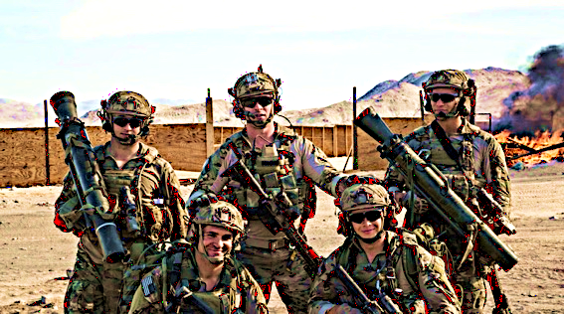
SCOTT’S RANGERS, 75th REGIMENT
Top: Carlos, Scott, and Nick.
Bottom: Hammer, Lara

Scott Adams is a born leader. When training at the US Army Officers School, he was promoted to a Ranger in the elite Special Forces unit. Other men asked to be a part of whatever team he led. In Afghanistan their combat moniker was Scotty’s Wranglers. They were assigned the most dangerous missions.

Hammer, 6’4” tall and a solid 240 pounds. He was Scott’s Executive Officer and self-appointed bodyguard. He fell for Lara, a teammate, but was too shy to express his feelings or make a move on her.

Lara, called Hot Lips because of her full lips and hot temper, was the squads Farsi translator and high-tech geek. She elicited information from captives and served as the squad’s communication specialist.

Carlos, the silent one but with a dry wit, is a born assassin who holds the Army sniper record kill at 3,540 meters. A Mexican Immigrant but now an American Citizen, he often quipped that the tepid heat of the Afghan desert heat was too cold for him and the spicy hot Afghan food was too bland.

Slick was a Detroit ghetto gang member who killed “rag head terrorists” without remorse. But he was a softy for the war-worn locals with whom he shared K-rations and to whom he gave money.

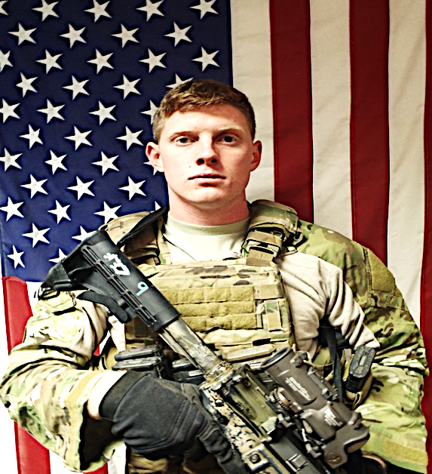
HANK (HAMMER) HARLAN, (30)
Scott’s Ranger XO and
Trusted Personal Friend

Hank Harlan was Captain Scott Adams’ Sargent Major and Executive Officer in the 75th US Army Ranger unit when they served three tours in Afghanistan.
Hammer and Scott fought many bloody firefights, saved each other’s lives several times and became deep and trusting friends.

They saw many horrible atrocities by Afghan terrorists who slaughtered innocent villagers. Both men are scarred by their memories and haunted by their nightmares. When Hammer returns to civilian life, both he and Scott have trouble adjusting socially and finding work.

He returned home to Texas but soon moved to San Jose to be closer to other Rangers, especially Lara. He secretly loves her but fears his redneck family would reject her because she is black. He wants Lara to accept him, but he is unsure of himself and fears her rejection.

After Scott inherits his windfall and Leilani is almost kidnapped by two homeless men, Scott asks Hammer to be his chief of security. He later asks him to be the third Knight of his Round Table of trusted friends.

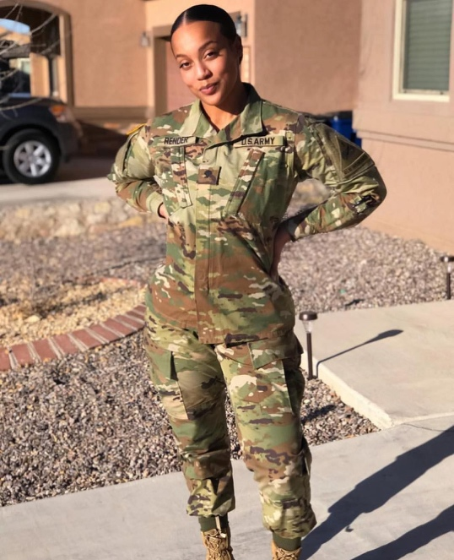
LARA “HOT LIPS” LAMAR, (28)
Scott’s Ranger Team

Lieutenant First Class Lara LaMar is a rare field officer in the US Army Rangers. She was recruited for her computer skills but quickly rose to the rank of IP Specialist.
Her father was an Iranian nuclear scientist who fled from the Sharia Mullahs to the freedom of America. He taught at the American University in Washington, DC where he met her mother, a brilliant and tenured black psychology professor.

Lara was assigned to the Rangers because she speaks fluent Farsi and effectively interrogates Afghan prisoners. She elicits information without torture and deciphers the enemy’s coded messages. With her top-secret clearance, she is authorized to transfer vast sums of money to local Afghan “friendlies”.

Lara’s Ranger Buddies nicknamed her “Hot Lips” because they loved the sexy smile behind her pouting lips. One Ranger in particular, Hank Hammer, is smitten by her exotic Iranian beauty, but he is intimidated by her intellect and high security clearance. He feels inferior, but tries to hide it.


SEAN (SMITTY) O’BRIEN, (63)
Special FBI Agent, West Coast Region Criminal Enterprise Division

Smitty O’Brien was the only undercover FBI Agent able to successfully infiltrate the Costellano crime family during their rise to power. His dangerous undercover work led to the RICO Act convictions and life sentences for Antonio Costellano and four other East Coast Mafia family bosses.
As the primary Agent on the RICO bust and its main trial witness, Smitty felt compelled to attend Antonio Costellano’s release from prison when the governor pardoned his life sentence.

After the detonation of the limousine that killed Antonio Costellano, Smitty and his assistant, Carmen, stopped at the accident scene to investigate and they discovered the cell phone that triggered the explosion.

Smitty suspects Antonia Costellano for the murder of her father and still wonders who has Antonio’s money, which the FBI never found. Smitty’s supervisor grants him time to get leads and find the money.

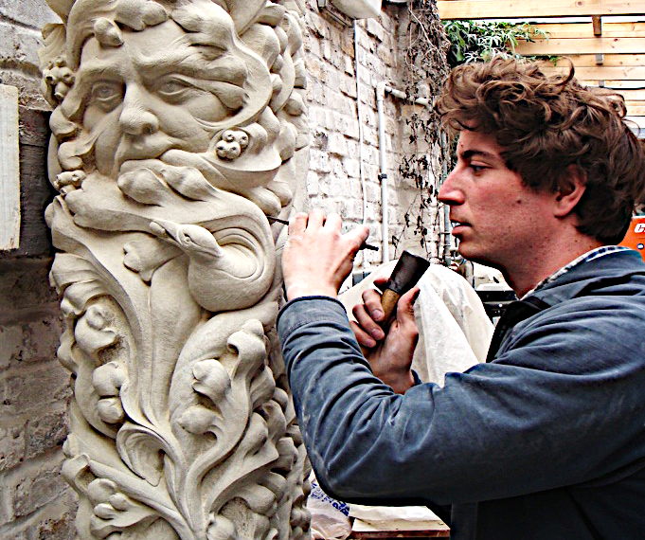
TIM HUNTER (32)
Big Sur Sculptor

TIM Hunter is a local Big Sur sculptor and bachelor who helped Scott and Uncle Al restore the Big Sur Cabin. He volunteered to clear the canyon trail and clean out the cabin’s gravity-fed water system.

In high school Scott and Tim were distant friends and chatted about girls, ideas and their future, but were never close.

When Scott returned home with his beautiful Hawaiian fiancé, they lived in the Big Sur cabin. Tim’s subtle flirtations and Leilani’s innocent enjoyment of them triggers Scott’s jealousy, insecurity and anger.
Tim’s sculptures are displayed in the same local gallery with Leilani’s paintings. Their common interest in art and passion for creativity further troubles Scott.

Tim is attracted to Leilani but he holds back his feelings for fear of losing Scott’s friendship. But as the inheritance creates tension between Scott and Leilani, Tim becomes emboldened and competes for her attention.

